9 February 2007 The Weekly Bulletin of Rotary Club of Kathmandu Mid-Town Bc # 32 of 2006-07
Rotary Club of Kathmandu Mid-Town
Breakfast Chatter




District : 3290 Web: www.rotarymidtown.org.np Club Id : 26776

FEBRUARY IS WORLD UNDERSTANDING MONTH
Demonstrate your commitment to promoting international understanding and goodwill by:
Planning and inviting public to a club program on Rotary peace activities in honor of World Understanding and Peace Day, 23 February
Sponsoring a Model United Nations program so that young people can experience the challenges and mechanics of global problem solving
Helping build friendly reciprocal relations with Rotary clubs in other countries by developing club-to-club links or by participating in an Inter-country Committee.
Encouraging ethnic diversity in club membership and inviting the participation of Rotary scholars, exchange students, and Rotary Foundation alumni in club activities
Sponsoring a peace-themed essay, art, or drama contest for youth, or using your international Rotary contacts to locate pen or e-mail pals for local youth.

Guest Speaker Dr Narayan Manandhar talked about Corruption and Development
at the Club meeting on 2 February 2007.
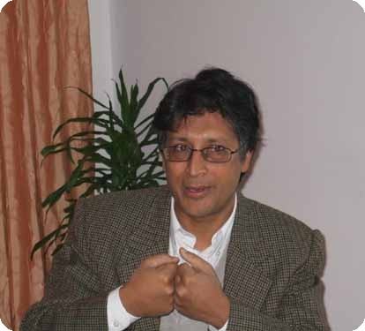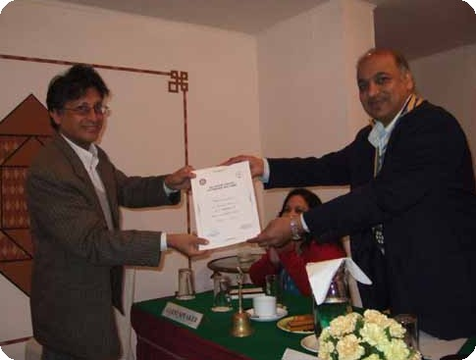
a) Dr Manandhar talking to club members during interaction after his presentation;
b) Guest speaker Narayan Manandar receiving Letter of Appreciation from President CK Golchha.

Weekly Meetings and Programs :
Date | Program/Speaker | Program/Topics of Presentation
9 Feb 2007 | Buddhi N Shrestha | Border management
16 Feb 2007 | Club assembly | Club assembly
23 Feb 2007 | No meeting | Weekly meeting combined with picnic on 24 Feb
24 Feb 2007 | Weekly meeting cum picnic | Sankhu

Friday, 9 February :
Buddhi N Shrestha, former Director General of Nepal government's Survey Department, and currently Managing Directorof Bhumichitra Mapping Company, will be talking on 'Multi-faceted' Border management between Nepal and India. He will provide a brief historical background of border management, closed, regulated and open border system between the two countries and discuss other border management issues.

Dental Awareness Camp at Ramkot :
A dental awareness camp was organized at Ramkot on Saturday, 3rd Feb 2007. The program was planned and coordinated by Rtn Dr Neil Pande in cooperation with Jayanti Youth Club, Ramkot. The camp was a great success as witnessed by the enthusiasm shown by the locals. Over 200 local people including students showed up in registration. Dr Neil Pande and his team provided general dental awareness including effective way of tooth brushing.
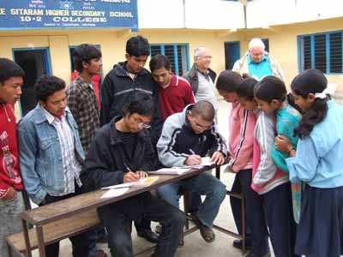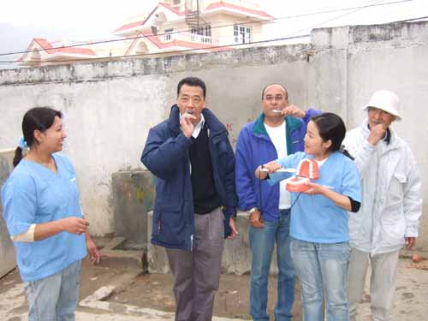
(a) Rotaracts busy on registration desk (b) Club members leading the way
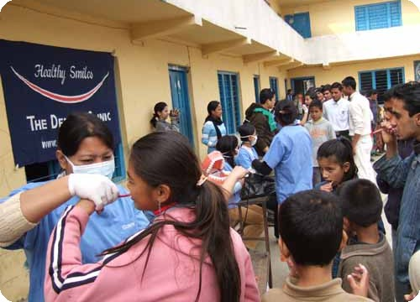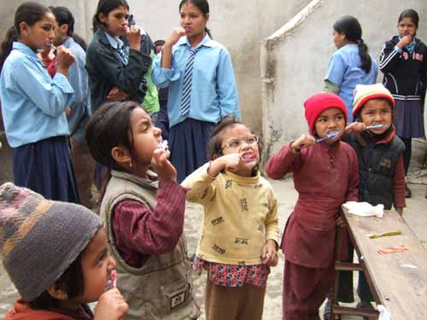
(c) Dr Neil and his team at work (d) Children learning tooth-brushing.

Career Counselling at Ramkot :
The Club organized a Career couselling for the students of Sitaram Madhyamik Higher Secondary School at Ramkot on Saturday, 3rd Feb 2007. The program was planned and coordinated by Vocational Service Director Govinda Chipalu in cooperation with Jayanti Youth Club, Ramkot. PP William Ma, IPP Komal Chitracar, President Elect Walter Diller and Club Service Director RR Shrestha volunteered in providing career counselling to students on developing career in tourism and travel business, business accounting, banking and airlines. Students did not show up for career counselling in engineering and medical doctor.

On Lighter Side : Click at the figure ⇩


As we enter World Understanding Month, we are reminded by Bangladesh Professor Muhammad Yunus' achievement that we can never know every consequence of what we do. His loan of $27, given in compassion, led to far more good than he could possibly have imagined.
RI President William B. Boyd

9 February 2007 The Weekly Bulletin of Rotary Club of Kathmandu Mid-Town Bc # 32 of 2006-07

Editor: RR Shrestha, Club Service Director email: rryes@wlink.com.np

